REGISTRATION FEE

52 weekly payments of $35.00 per person*
Name: __________________________ Address: _______________________
Street: __________________________

City: ___________________________

State, Zip: _______________________

Phone: (______) _________________

Church: _________________________

Pastor: __________________________
Amount Paid: ______________

Registration Fees are non-refundable

*Prices are subject to change.

Make checks/money orders payable to:
Karen Robinson Ministries Inc.
Karen Robinson Ministries Inc.
PO Box 7056
Wilmington, DE 19803
Phone: 302.633.6972
Fax: 302.633.6972

Website:
www.krministries.org Email: krministriesinc@yahoo.com
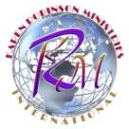

KRMI MINISTRIES

Repairers of the Breach
Biblical Counseling Program
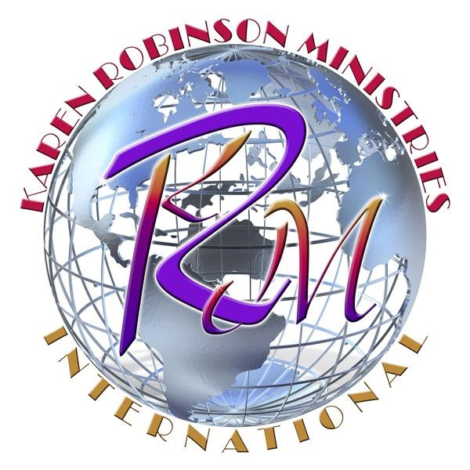
“The training institute, where Balance, Protocol and Order are established”
Phone: 302.633.6972

MISSION STATEMENT
Karen Robinson Ministries, Inc. (KRMI) primary mission is to facilitate and enhance the spiritual and personal growth of those who are called today to prophetic ministry and church leadership, and to prepare them to respond efficiently to the leadership challenges of tomorrow.
KRMI undertakes this mission based on the firm belief that now more than ever, a critical need exists locally and abroad for persons of strong Christian character to elevate into positions of prophetic ministry and leadership.
KRMI is established for the purposes of training and developing individuals to become prophets and servant leaders by cultivating the "spirit of excellence" within them; equipping them to skillfully apply Biblically-based principals of ethics, integrity and character essential to the benevolent and effective functioning of the institutions that impact our communities.
KRMI seeks to identify and minister to those who are chosen by God to serve in the positions and responsibilities of leadership (be it in the church or secular realm), by providing prophetic and leadership skills necessary to operate in the capacity God has called them to serve.

COURSE DESCRIPTION
This is a one-year course primarily for those who have a strong desire to learn the process of biblical counseling. It will provide much teaching and clarity on the "ministry of biblical counseling". It will also include role-playing exercises and training on how to properly prepare for a case. You will be properly trained on techniques of how to handle this ministry gift with effectiveness.
After the completion of this course, you will have learned the basic techniques for effective biblical counseling by presenting a system of biblical truths that will help bring change, restore relationships, help solve problems, and restore fellowship back to God.
Each student will receive a certificate of completion. If you have a strong desire to learn the process of biblical counseling, then this course is for you!! Enroll now to begin equipping yourself with this invaluable training! On-Campus classes begin 9/9/17 – 8/11/18 from 11:00am -2:00pm every Saturday in Wilmington, DE. On-line classes begin same day for one-year.

COURSE OUTLINE
Tools Needed for Effective Biblical Counseling
Learning the Principles of Biblical Counseling
How to Locate the Four Problem Levels in Biblical Counseling
Learn To Effectively Counsel Yourself
How to Effectively Counsel Others
Role Playing
How to Prepare a Case
AND MUCH, MUCH, MORE!

