REGISTRATION SCHEDULE
(CIRCLE ONE)

Plan A: Groups of 20 people: $45.00 pp
Plan B: Groups of 25 people: $35.00pp
Plan C: Groups of 30 people: $30.00pp
Plan D: Groups of 50 people or more: $25.00pp Name: ___________________________
Address: _________________________
Street: ___________________________

City: _____________________________

State, Zip: ________________________

Phone: (______) __________________

Church: __________________________

Pastor: ___________________________
Amount Paid: _____________________

Registration Fees are non-refundable
Make checks/money orders payable to:
Karen Robinson Ministries Inc.
Karen Robinson Ministries Inc.
PO Box 7056
Wilmington, DE 19803
Phone: 302.633.6972
Fax: 302.633.6972

Website:
www.krministries.org Email: krministriesinc@yahoo.com

KRMI MINISTRIES

The Judah Leadership
Ministry Training Program
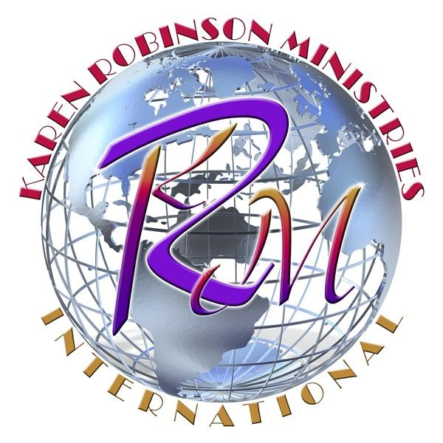
“The Leadership Training program, where, Balance, Protocol and Order are established”
Phone: 302.633.6972

MISSION STATEMENT
Karen Robinson Ministries, Inc. (KRMI) primary mission is to facilitate and enhance the spiritual and personal growth of those who are called today to prophetic ministry and church leadership, and to prepare them to respond efficiently to the leadership challenges of tomorrow.
KRMI undertakes this mission based on the firm belief that now more than ever, a critical need exists locally and abroad for persons of strong Christian character to elevate into positions of prophetic ministry and leadership.
KRMI is established for the purposes of training and developing individuals to become prophets and servant leaders by cultivating the "spirit of excellence" within them; equipping them to skillfully apply Biblically-based principals of ethics, integrity and character essential to the benevolent and effective functioning of the institutions that impact our communities.
KRMI seeks to identify and minister to those who are chosen by God to serve in the positions and responsibilities of leadership (be it in the church or secular realm), by providing prophetic and leadership skills necessary to operate in the capacity God has called them to serve.

COURSE DESCRIPTION
This is a one-year training program for those who are called to leadership. The course will provide substantial instruction and clarity on the role of spiritual leadership. You will learn the essential qualities of servant hood and leadership, prayer and leadership, the cost of leadership and the responsibilities of spiritual leadership in the kingdom of God.
This workshop will help you to improve on your leadership skills. You will be taught how to serve effectively in the local church with the spirit of excellence in the House of God and the people of God as well as how to serve the men and women of God to whom you submit.
After the completion of this workshop, you will have a better understanding of your role as God's chosen leaders and the confidence to fulfill your assigned task. Each person will receive a certificate of completion.
On-Campus classes begin 9/9/17 – 8/11/18 from 11:00am -2:00pm every Saturday in Wilmington, DE. On-line classes begin same day for one-year. Future leaders, enroll now to begin equipping and empowering yourself with this invaluable training!

COURSE OUTLINE
Leaders & Prayer
Leaders Who Are Problem Solvers
How Leaders are Found
Spiritual Leadership Principles
What Kind of Leader Are You?
Seven Essential Qualities
Leaders & Protocol
Leaders & Character
Leaders Who Are Willing To
Leave to Cleave
Leaders & Authority
Leaders, Timing & Preparation
AND MUCH MUCH MORE!

